**4 Functional requirements**

The software has to comply with the following functional requirements:

1. Means of identification of class related components

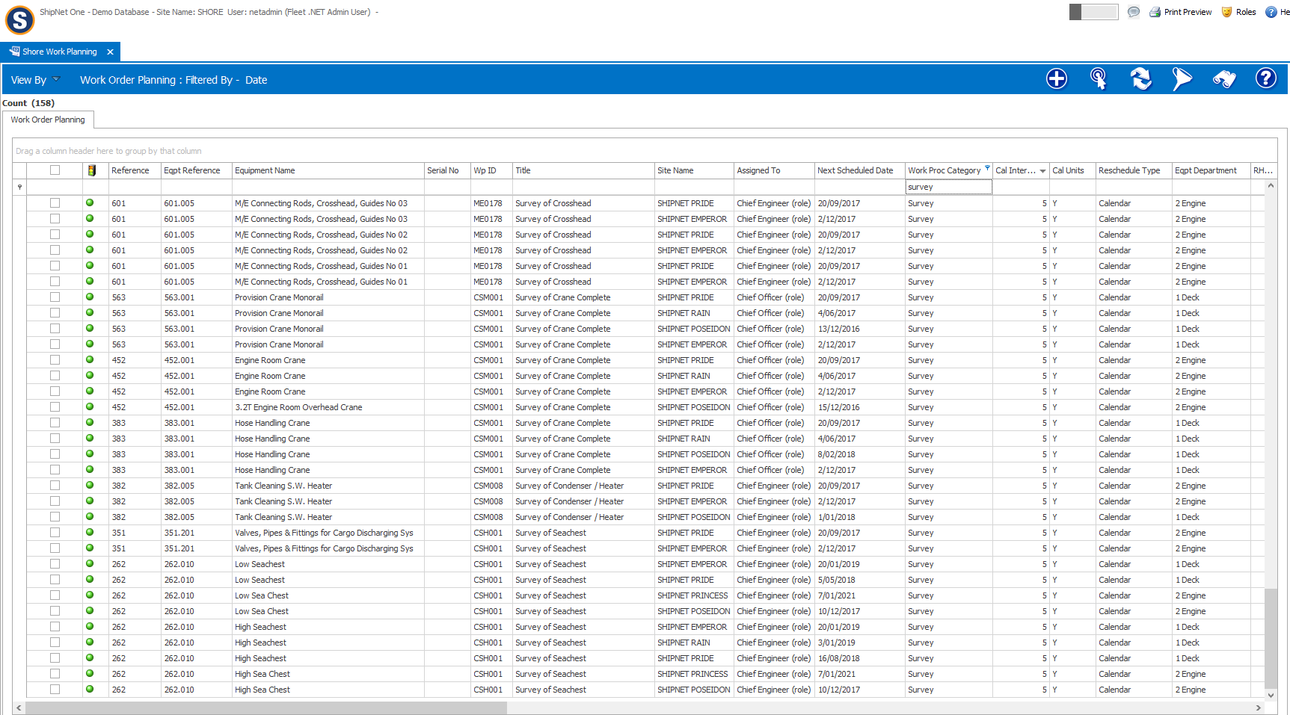

1. Capability to handle maintenance related information
2. Job descriptions / work orders

Work Planning & Work Order Packaging

## Overview

Work Order Packaging is a new concept developed with futuristic intentions to integrate into new modules like Repair & Break Down Management, Dry Dock Management, etc., Work Planning and Work Order Manager screens have an enhanced look and feel and improved performance from Legacy product.

## Key Features

* Allows Work Order Packaging to plan PMS Jobs or based on their occurrence as a Dry Dock or Survey Jobs.
* Work Planning is integrated with interactive Graphical interface.
* Job Grouping is integrated to simultaneously create WO for grouped WP.
* Advance Search facilitates user experience.
* Links to Procurement System – if user requires to create Requisitions or would like to see pending orders.
* Links to Safety & Risk Assessment.
* Clarity in information communicated between Chief Engineer & Superintendent.

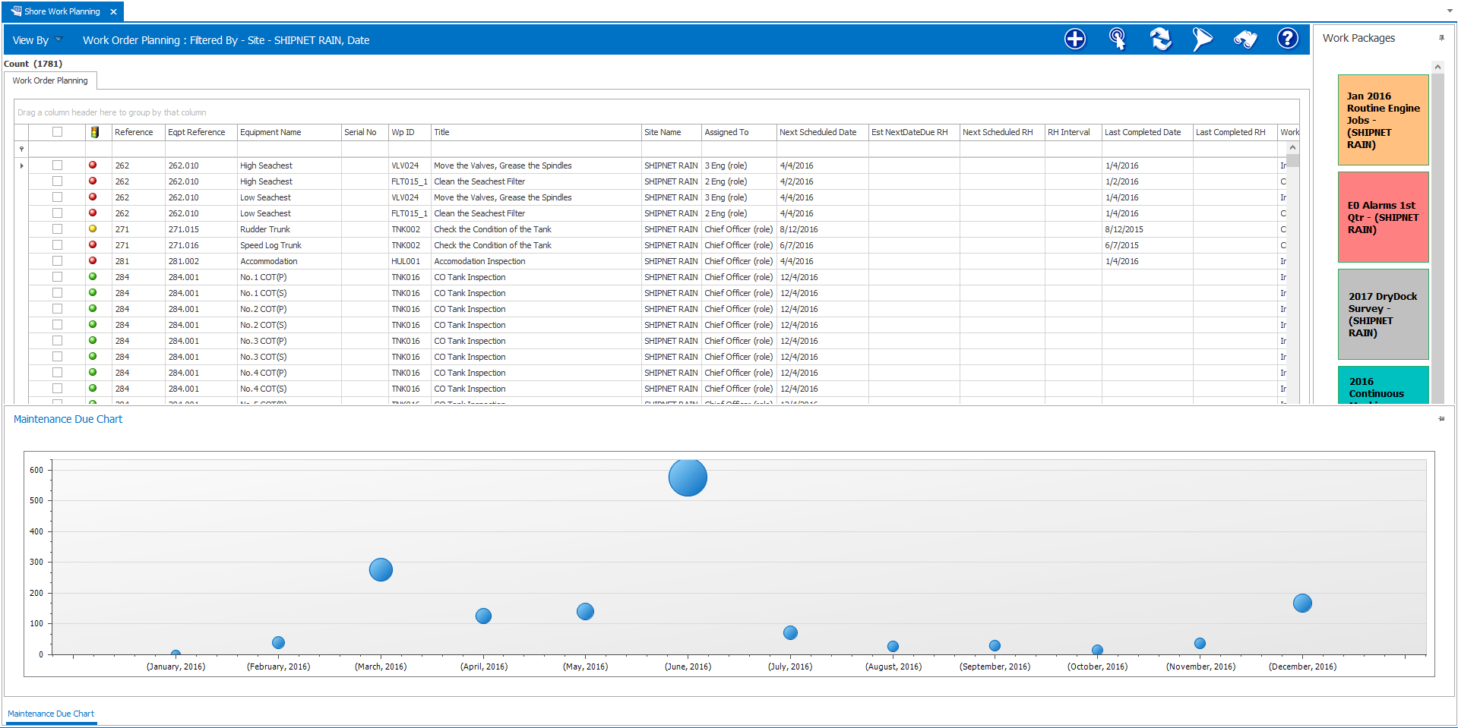

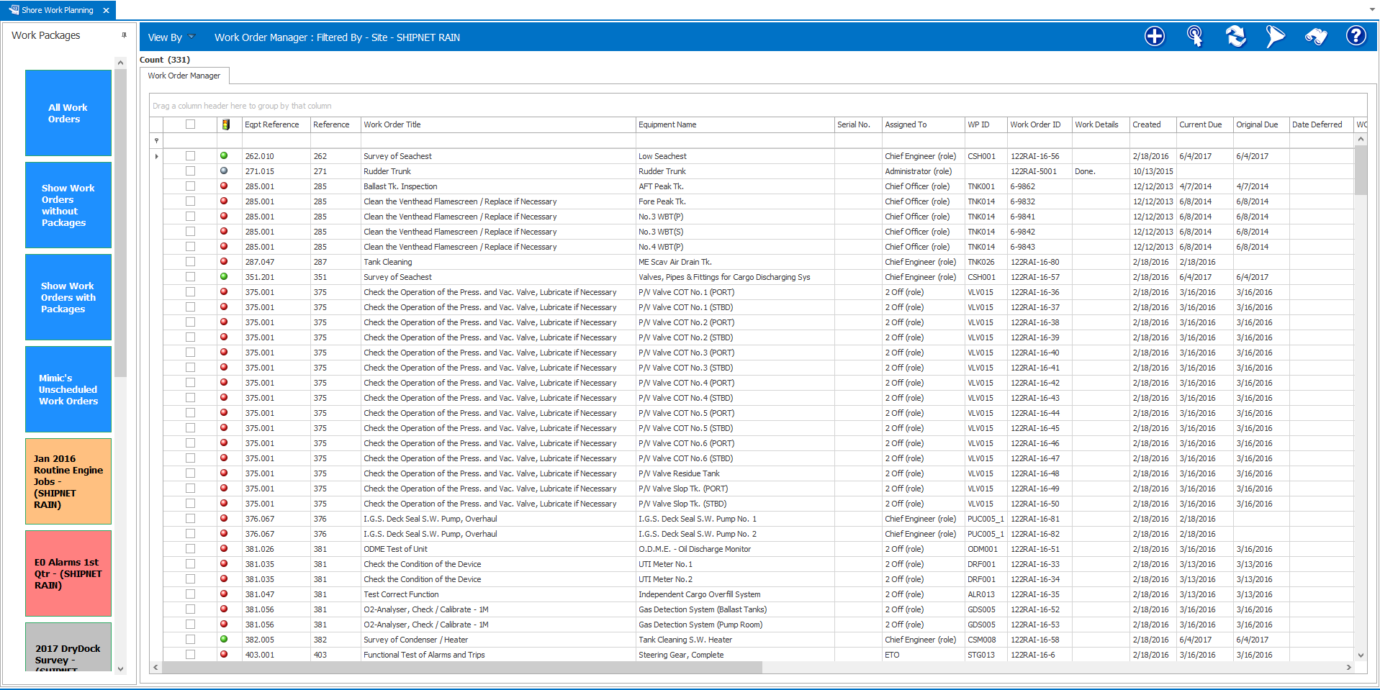

1. Maintenance intervals (running hours / calendar based)

ShipNet One can hold Equipment Maintenance with frequency both Running hour & Calendar based. Following screenshot shows a consolidated list in a Grid Explorer (Work Planning) with all maintenances for a period.

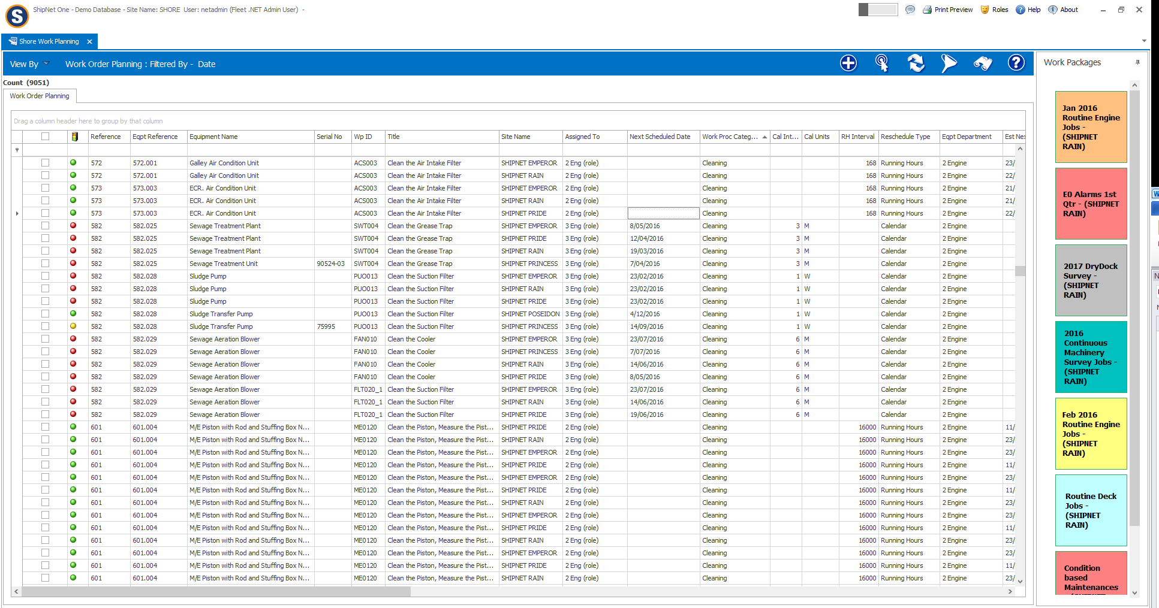

1. Continuous improvement process (e.g. following up of deficiencies, failure reports, user feedback, Etc.)

Occurrence Management System – this is integrated in ShipNet One to create Deficiency Report & Repair / Breakdown to follow-up on the task involved. In addition, ShipNet One allows user to link this with the reported equipment & also create a Work Order for the task.

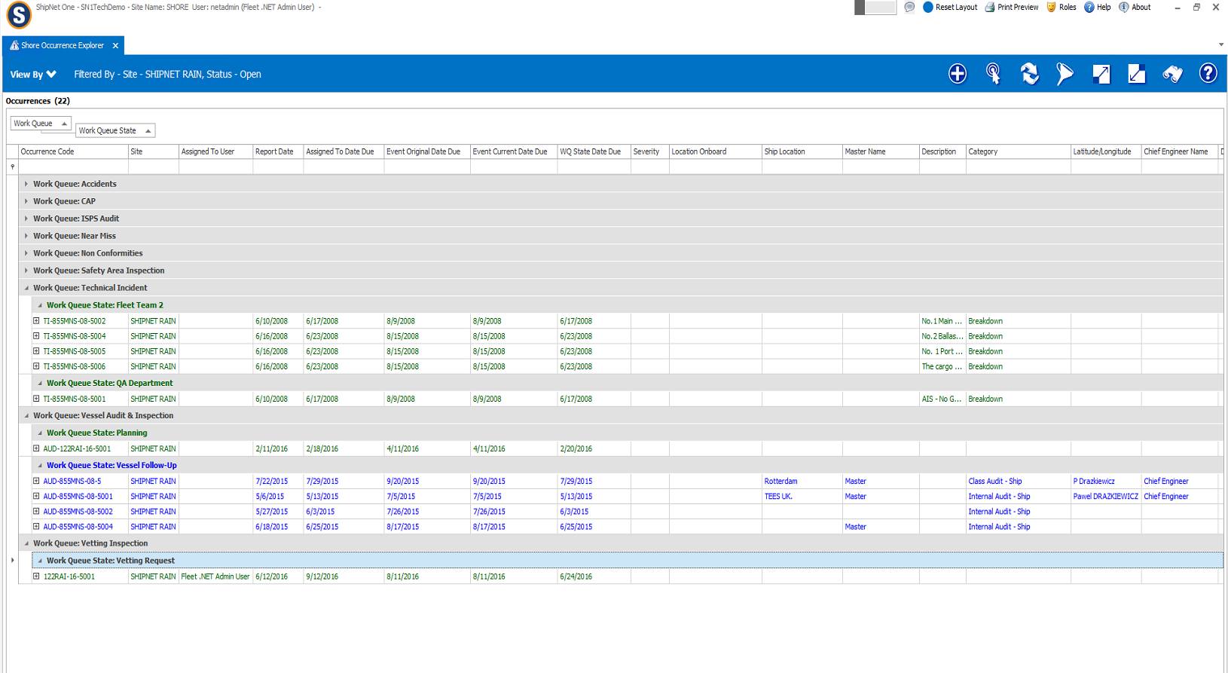

1. Maintenance types
   1. Planned

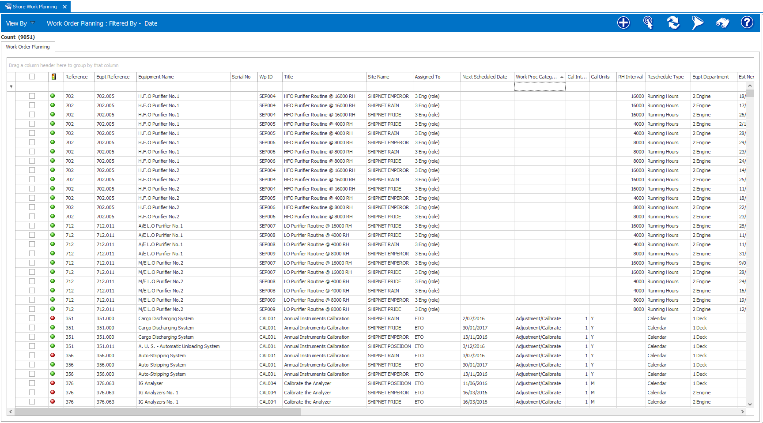

* 1. Unplanned / corrective

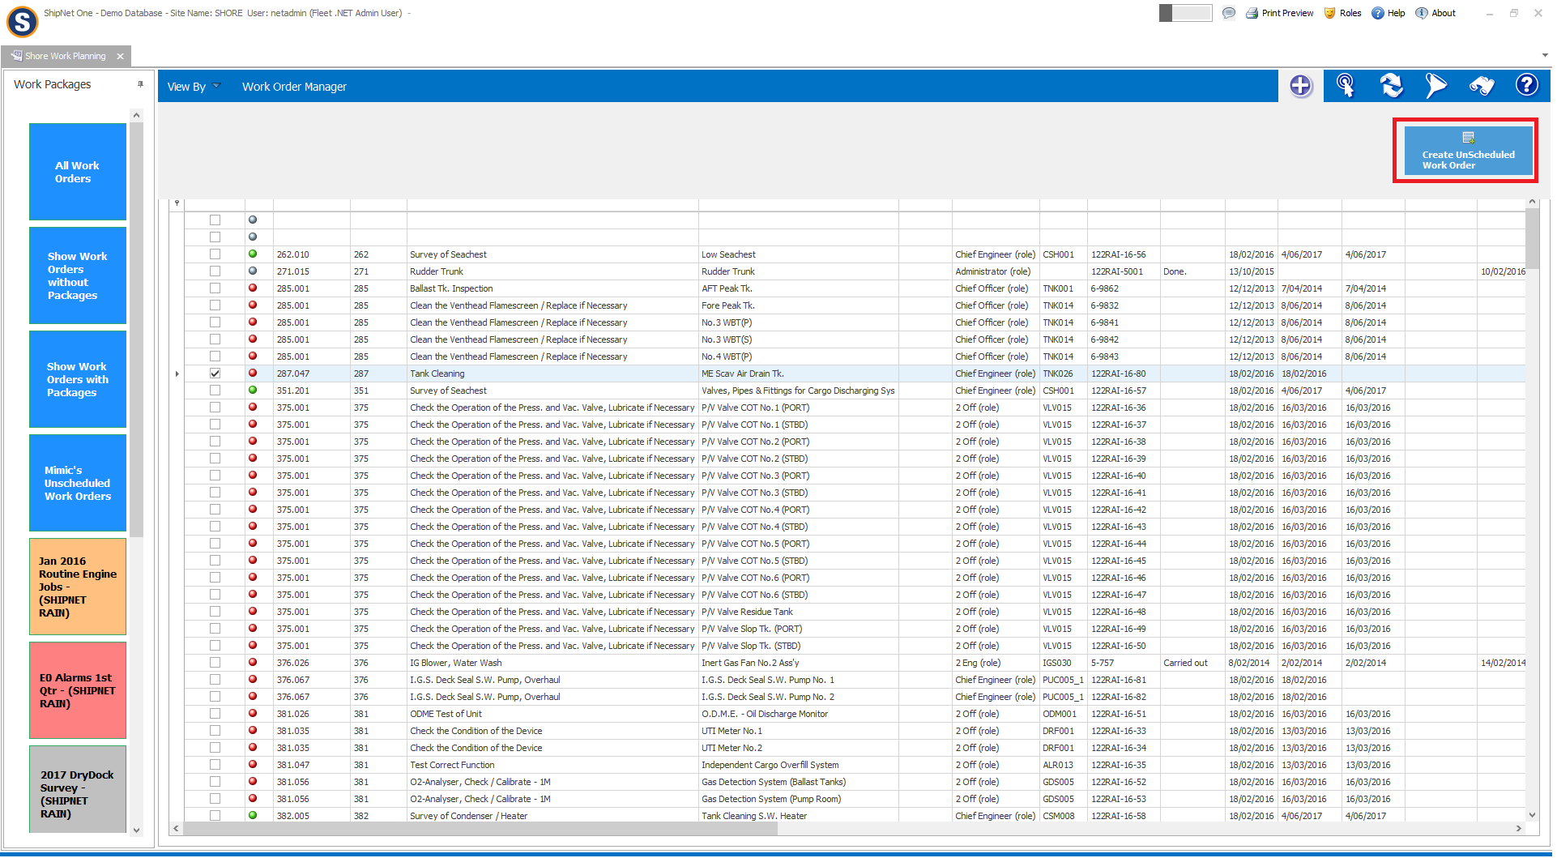

* 1. Postponed / deferred

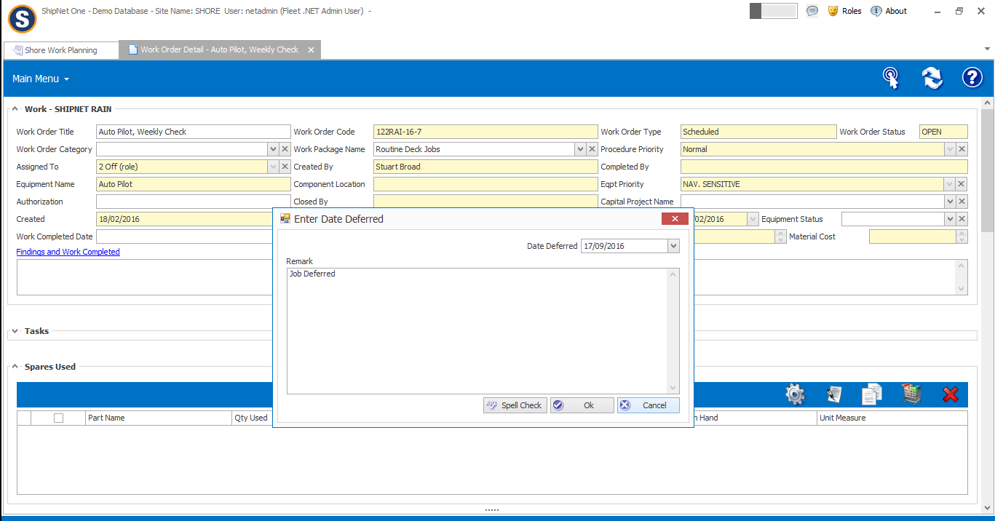

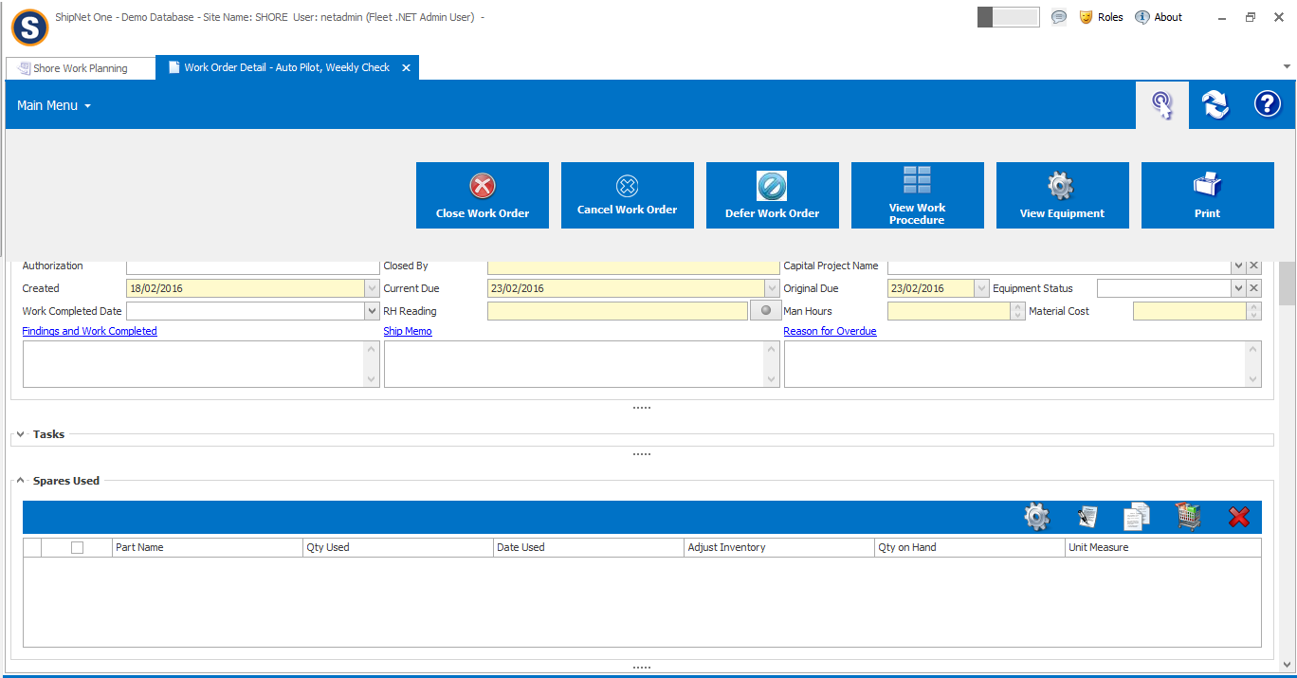

* 1. Overdue.

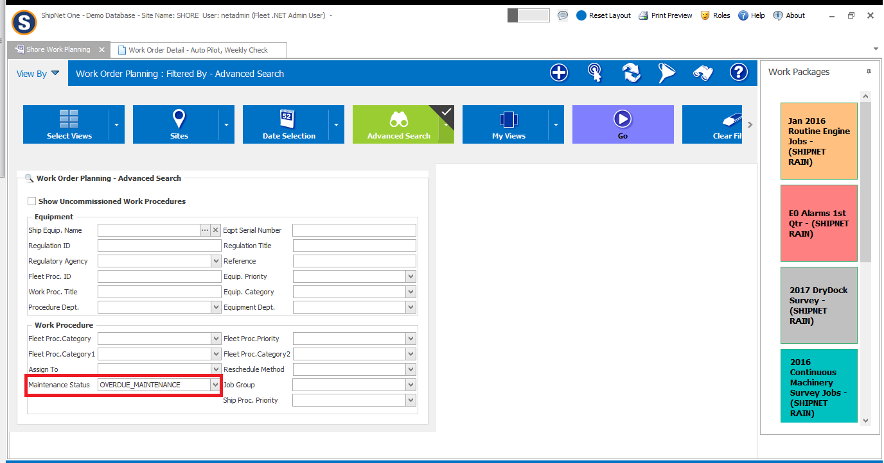

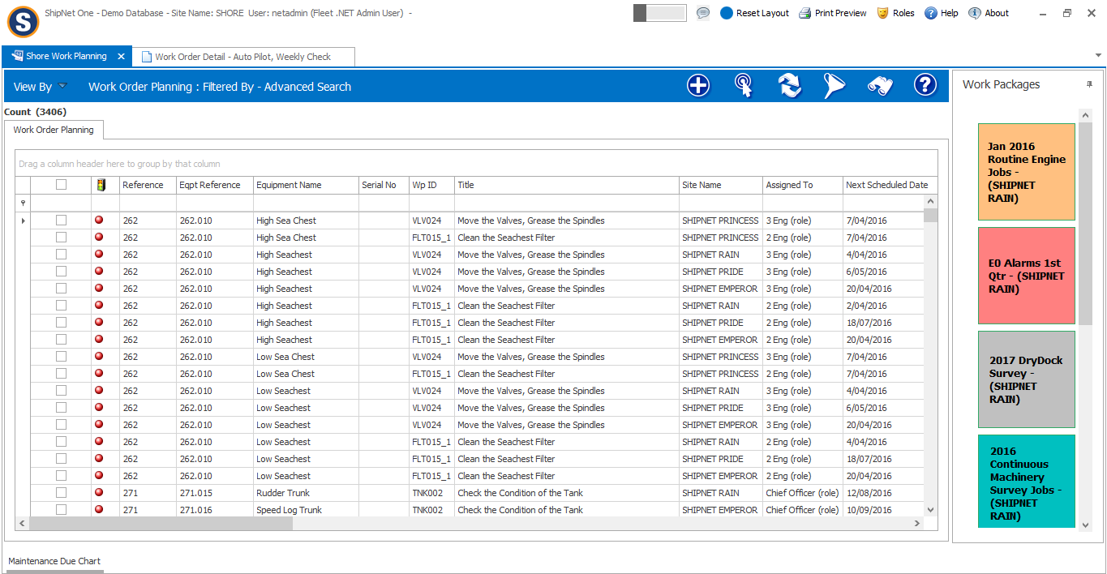

1. Alarms for unattended machinery spaces.

ShipNet One has various categories available to filter out Alarm Jobs for UMS ships. As in below screenshot, EO Automation can be a category to filter out Alarms for UMS.

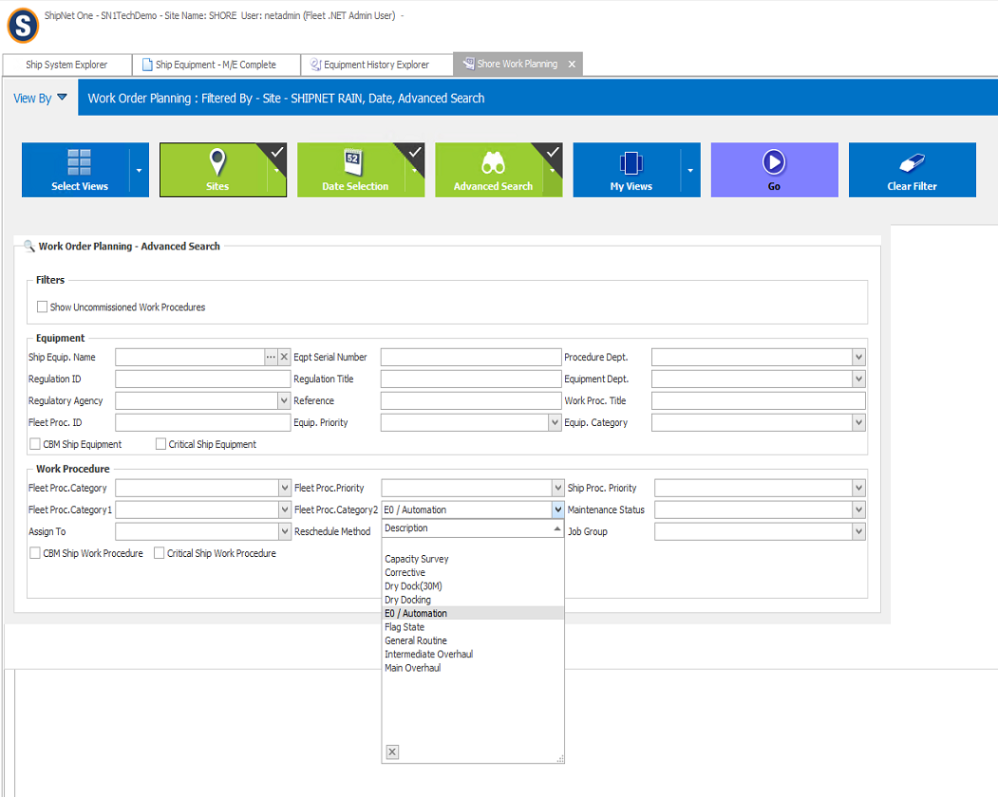

1. Search and filter functionality for
   1. Class related components
   2. Class related maintenance types
      1. Historical jobs
      2. Upcoming jobs.

Search & filter is available in every screen of ShipNet One. As in below screenshot of Equipment history – a search can be run to take out all Class Related Component & Maintenances with Historical data. Similarly, in Work Planning screen a similar query can be run to take out all Class related maintenances falling due in future.

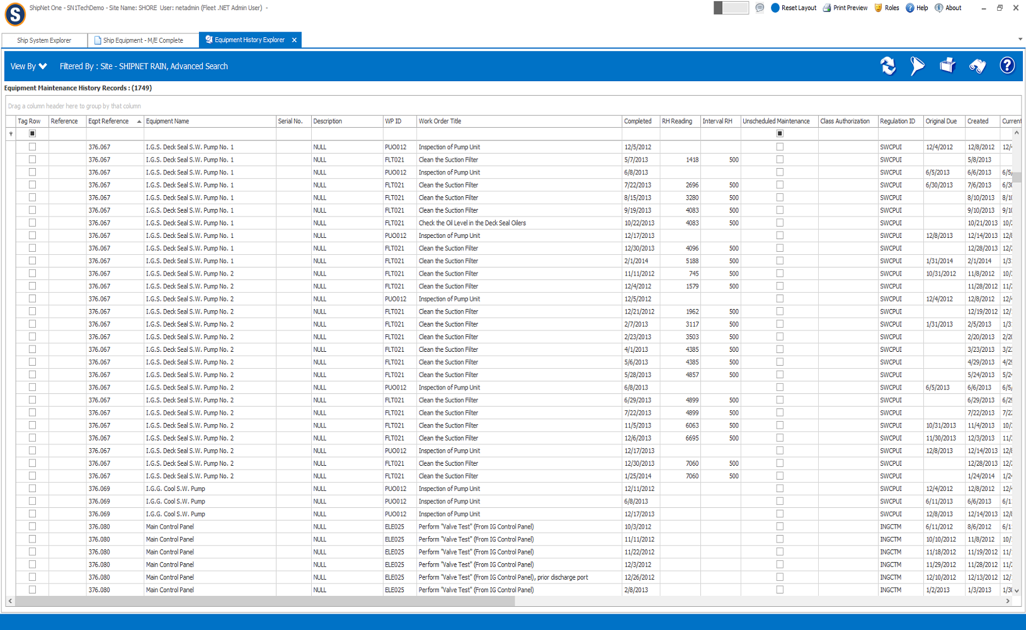

1. Traceability
   1. Circulating components

ShipNet One has capability to track Component rotation for Unit Based ship equipment. Following screenshot shows an example of a typically configured Rotating Component Explorer.

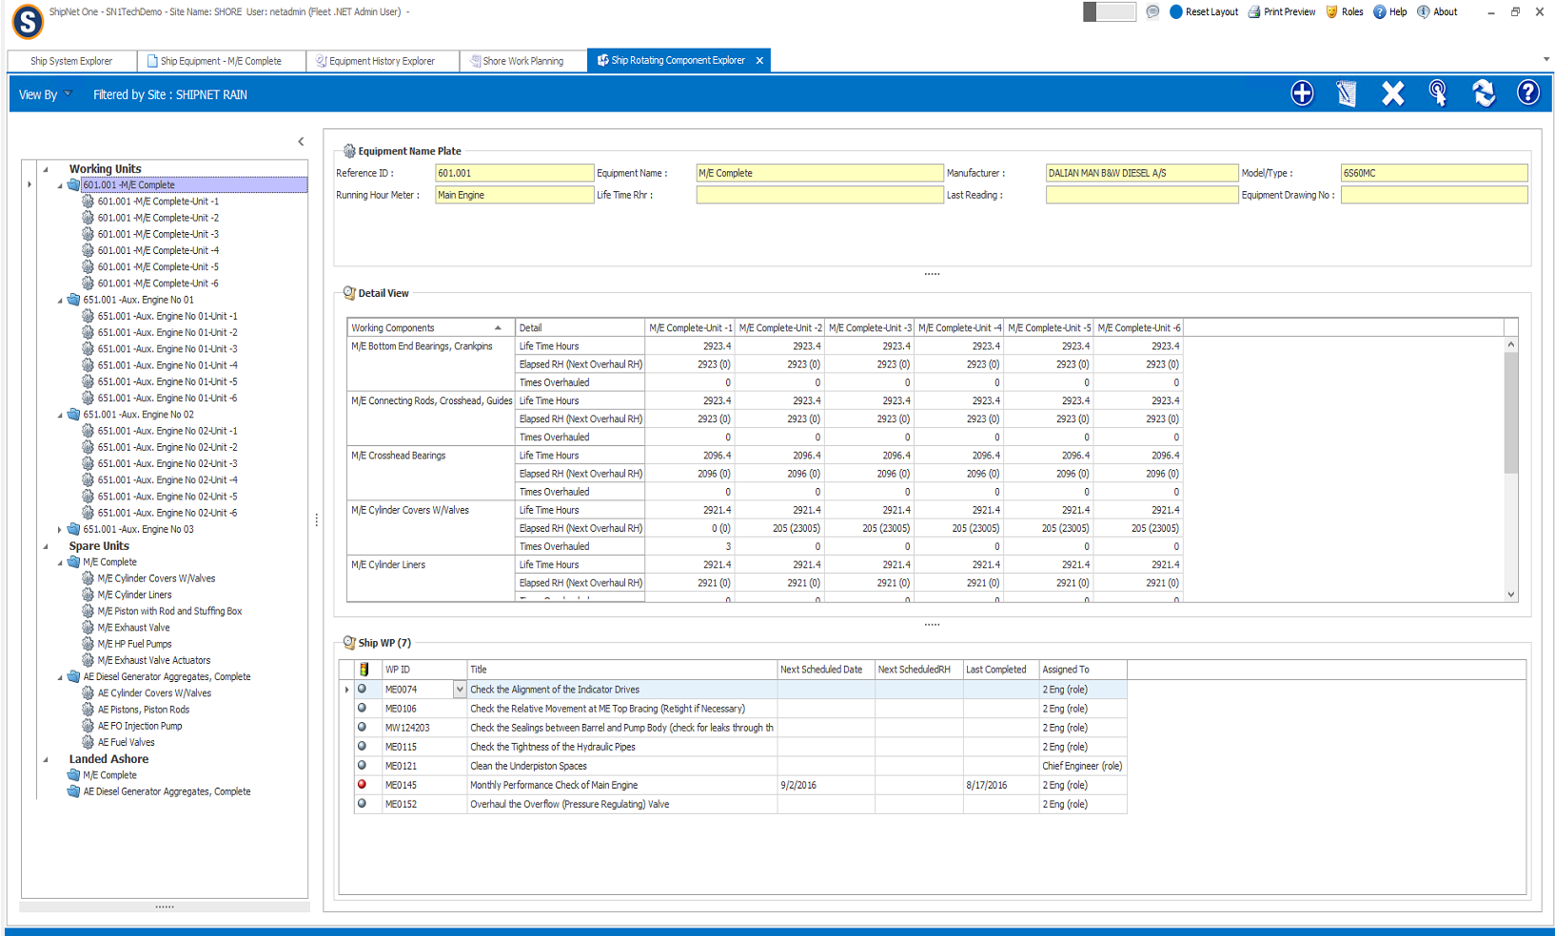

* 1. Audit logs

A comprehensive Audit log that tracks every change in the system at the replication level. The replication level is the point where database changes are transported to the other site and vice versa.

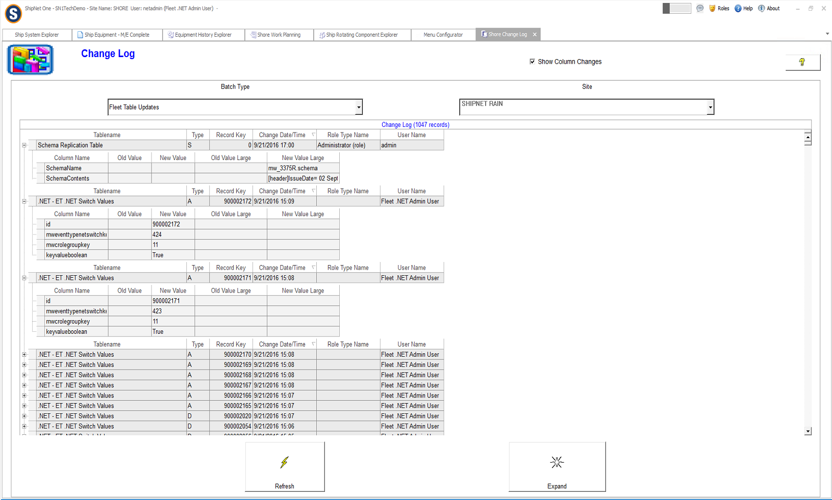

1. Access control
   1. Support different levels of user access

Access Control in ShipNet One is developed to support access rights at User level / Role Level / Site Level / Fleet Level & Company level.

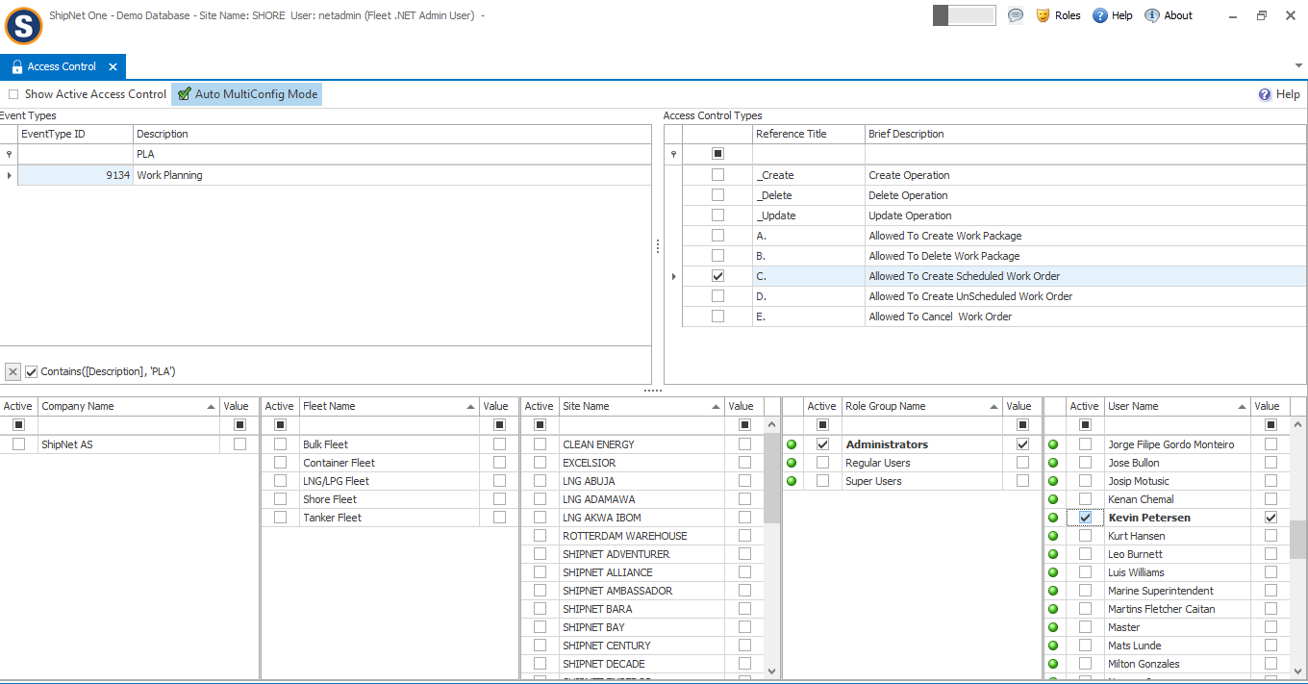

* 1. Support administrative access.

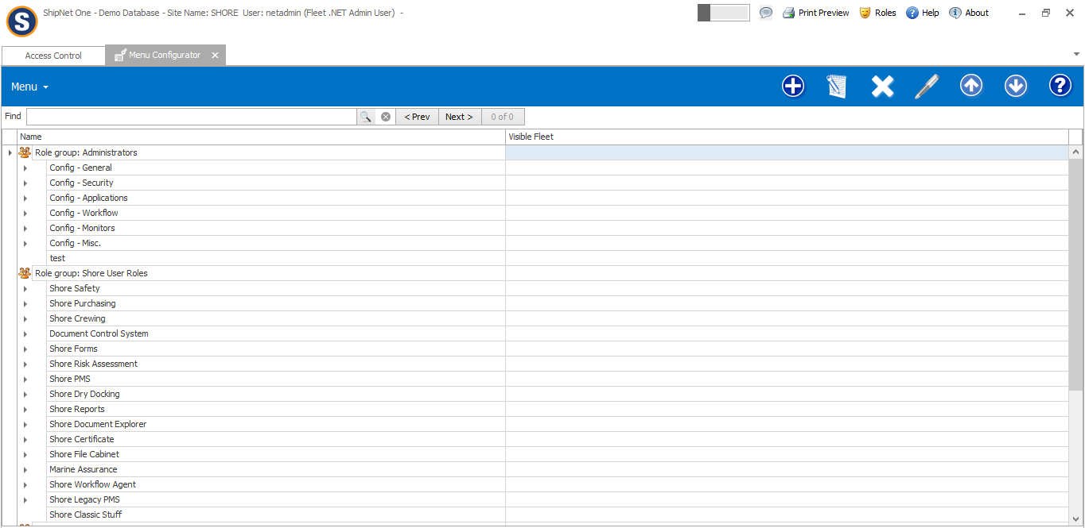

1. Exporting functionality
   1. All results from items 1 – 3 shall be available as reports

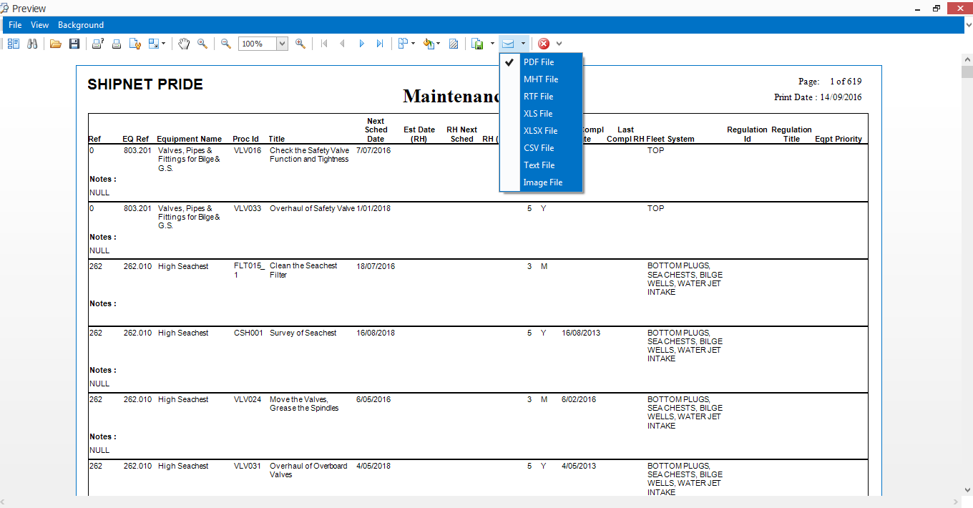

* 1. All reports from the system shall be vessel and system specific (non-editable onboard)
  2. All class components in spreadsheet format
  3. All maintenance reports shall at least cover:
     1. Component name
     2. Job/ work order name
     3. Maintenance interval
     4. Date carried out
     5. Job/ work order history.

We can display all the reports as mentioned above.